- The model "meta-llama/llama-4-scout-17b-16e-instruct"provided in the postman is not supported the reasoning,
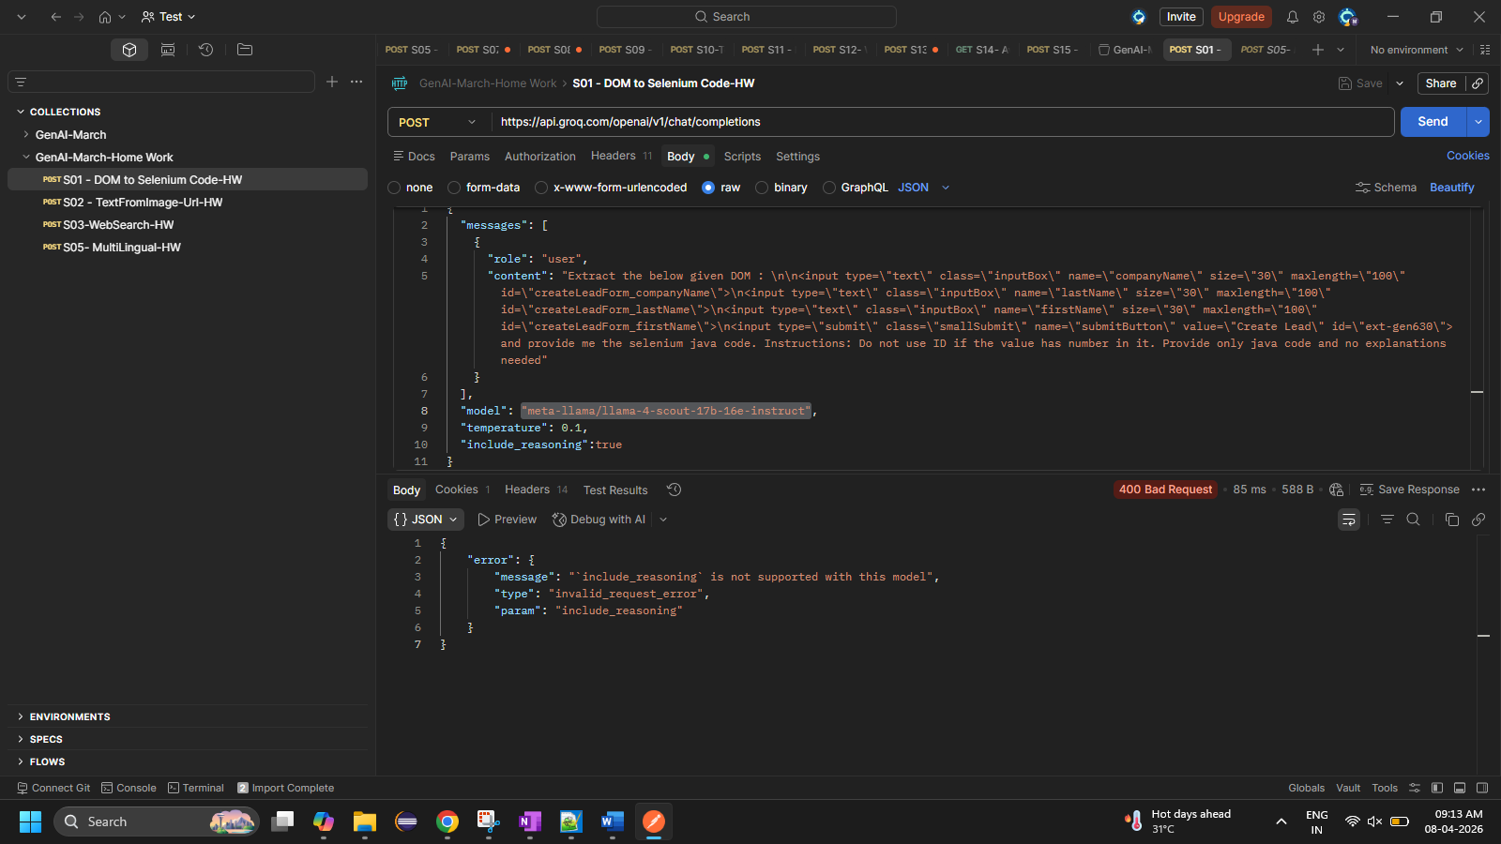

So I changed the model to this model “openai/gpt-oss-20b”
I got the output with reasoning
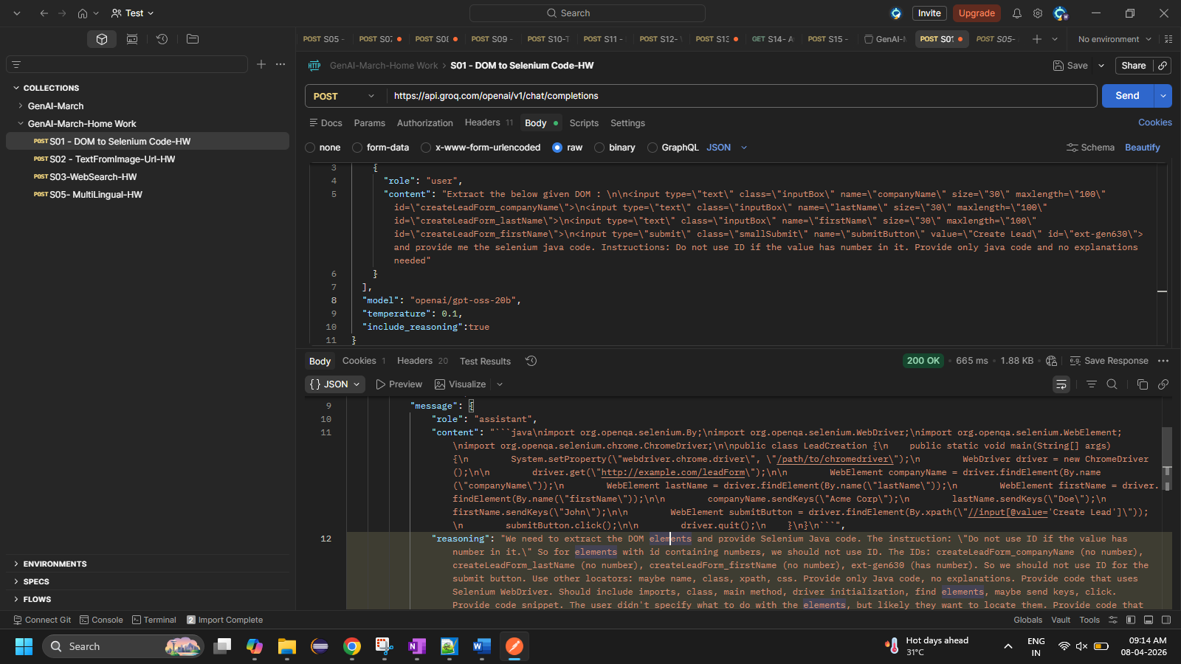

Response After beautify:
```java
import org.openqa.selenium.By;
import org.openqa.selenium.WebDriver;
import org.openqa.selenium.WebElement;
import org.openqa.selenium.chrome.ChromeDriver;

public class LeadCreation {
public static void main(String[] args) {
System.setProperty("webdriver.chrome.driver", "/path/to/chromedriver");
WebDriver driver = new ChromeDriver();

driver.get("http://example.com/leadForm");

WebElement companyName = driver.findElement(By.name("companyName"));
WebElement lastName = driver.findElement(By.name("lastName"));
WebElement firstName = driver.findElement(By.name("firstName"));

companyName.sendKeys("Acme Corp");
lastName.sendKeys("Doe");
firstName.sendKeys("John");

WebElement submitButton = driver.findElement(By.xpath("//input[@value='Create Lead']"));
submitButton.click();

driver.quit();
}
}
```",
"reasoning": "We need to extract the DOM elements and provide Selenium Java code. The instruction: "Do not use ID if the value has number in it." So for elements with id containing numbers, we should not use ID. The IDs: createLeadForm_companyName (no number), createLeadForm_lastName (no number), createLeadForm_firstName (no number), ext-gen630 (has number). So we should not use ID for the submit button. Use other locators: maybe name, class, xpath, css. Provide only Java code, no explanations. Provide code that uses Selenium WebDriver. Should include imports, class, main method, driver initialization, find elements, maybe send keys, click. Provide code snippet. The user didn't specify what to do with the elements, but likely they want to locate them. Provide code that finds each element and maybe interacts. Provide only Java code. No explanations. So produce code. Use WebDriver driver = new ChromeDriver(); etc. Use driver.findElement(By.name("companyName")).sendKeys("Acme"); etc. For submit button, use By.xpath("//input[@value='Create Lead']") or By.cssSelector("input[value='Create Lead']"). Provide code. Also maybe use By.className("smallSubmit") but that might match multiple. Use By.xpath. Provide code. Ensure no ID usage for submit. Provide code. Let's produce."

- Image to text convertor:
This is the image url provided in the api,
Image url: https://m.media-amazon.com/images/I/71S5VX9v70L._SX3000_.jpg
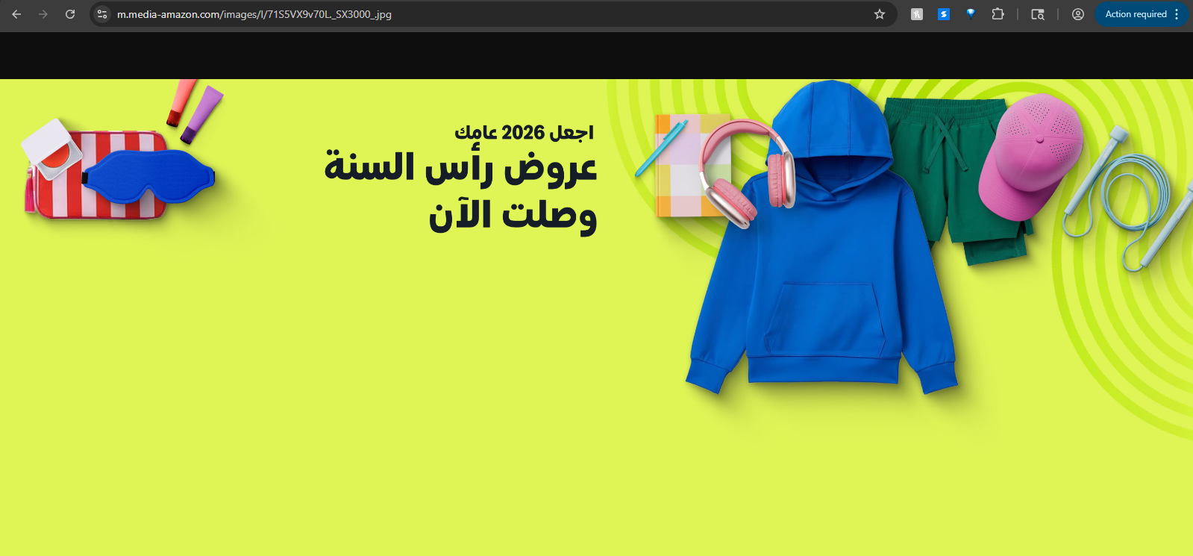

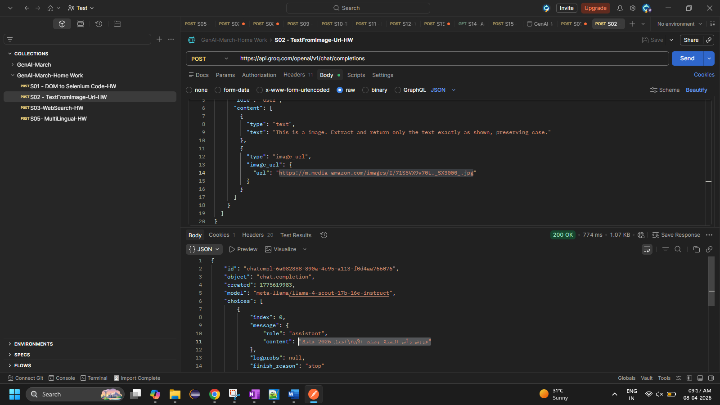

New image url : https://media.licdn.com/dms/image/v2/D5612AQHJHwKJBJV7sw/article-cover_image-shrink_720_1280/article-cover_image-shrink_720_1280/0/1736234363665?e=2147483647&v=beta&t=NgNW55mVs9RS-17dwWJswvnRBNf4uz5AOeWFZmjKlw0
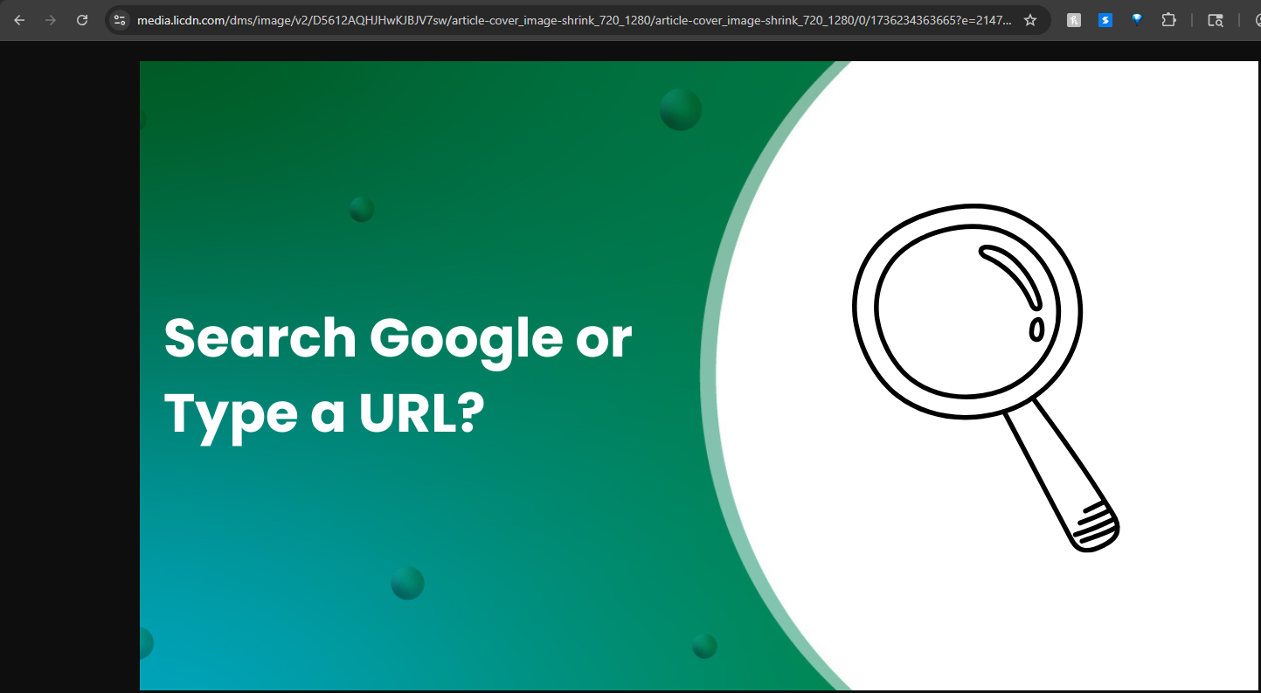

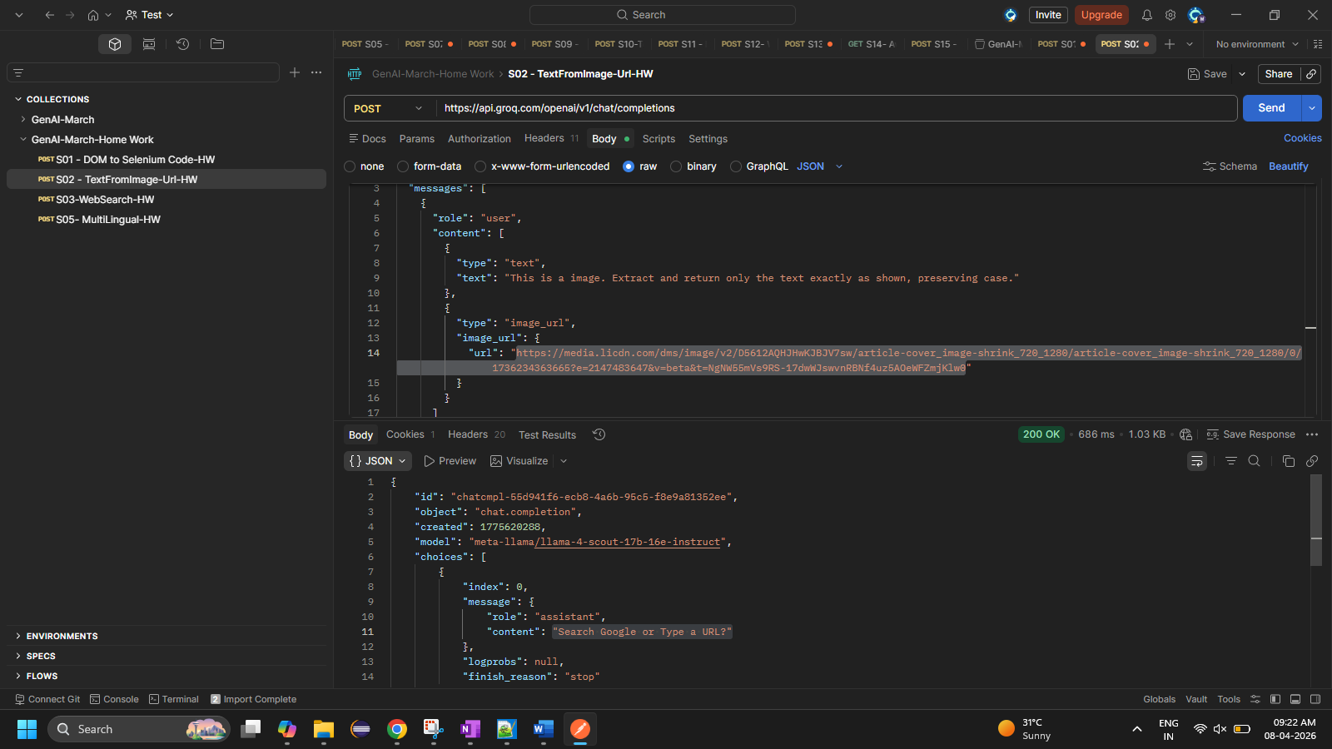
I got the output perfectly it fetches all the text in that image.

- Web search api:
I got the output 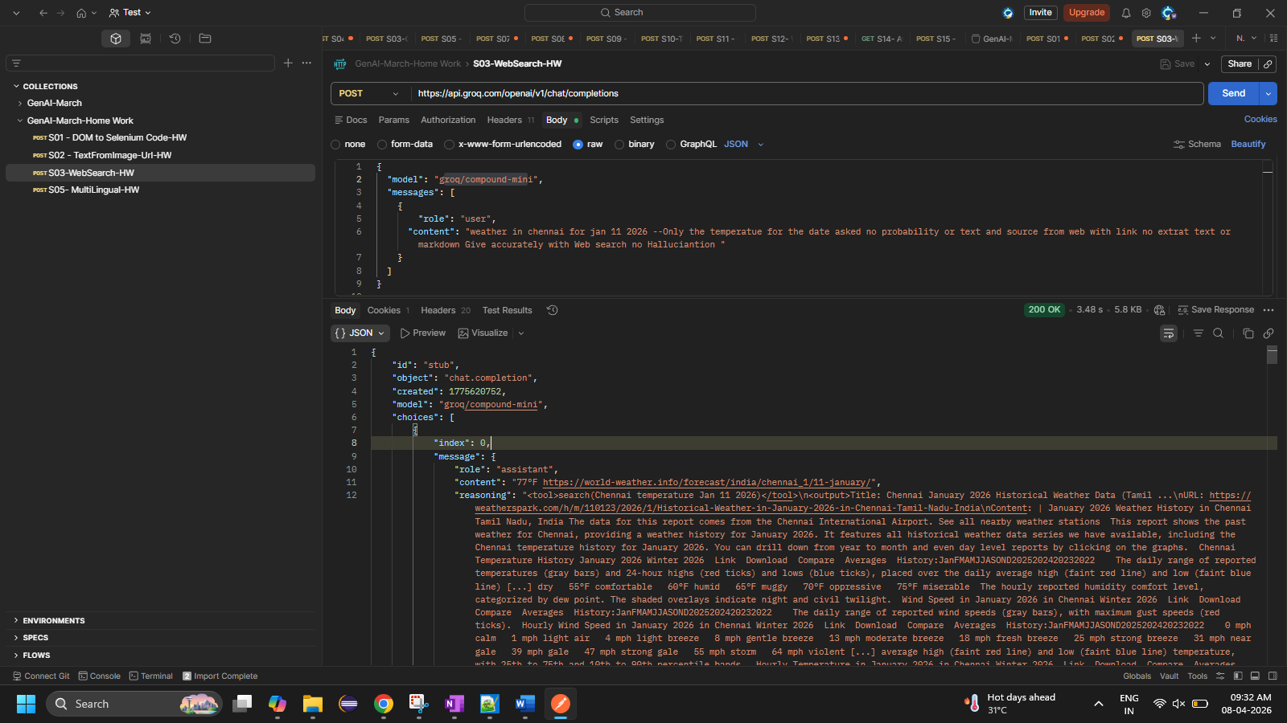

Not getting proper output on this model – “openai/gpt-oss-120b”
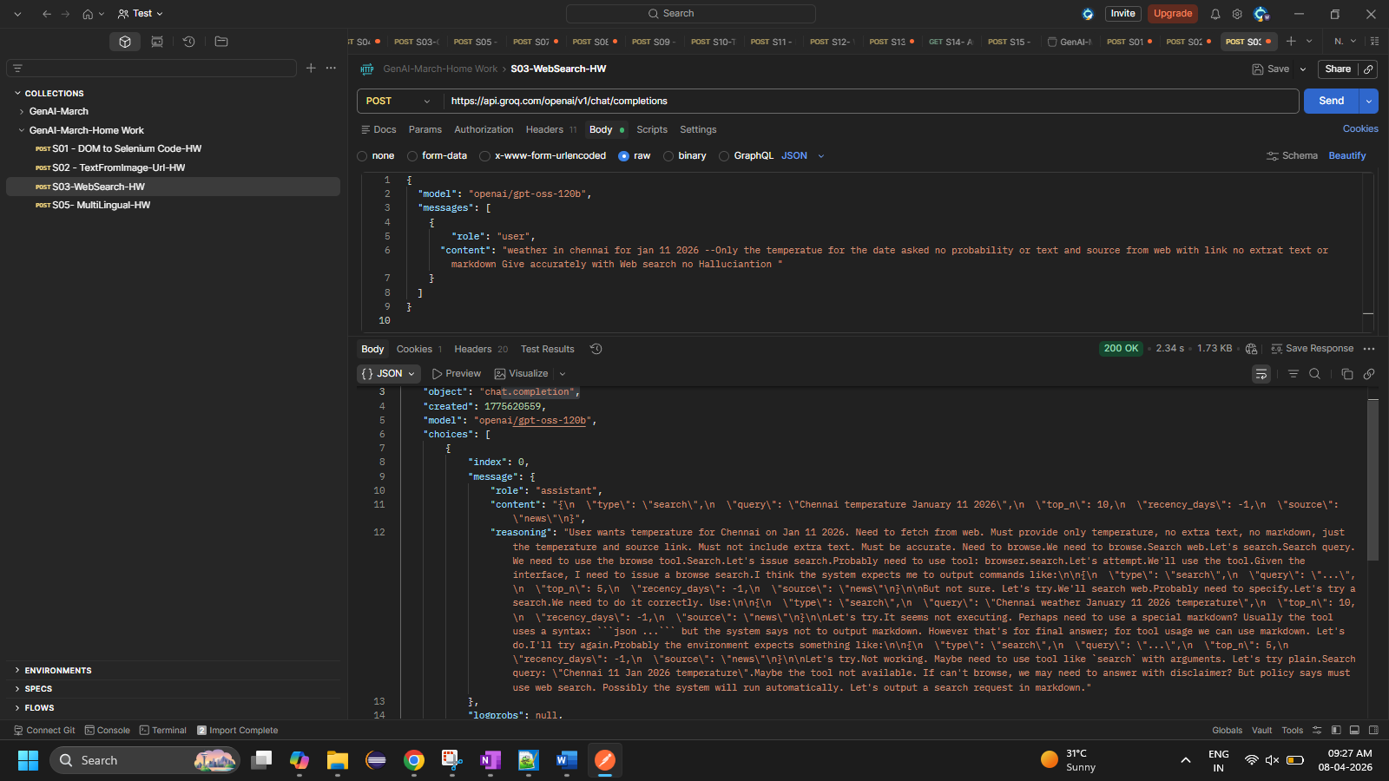

I asked about the gold rate to this api,
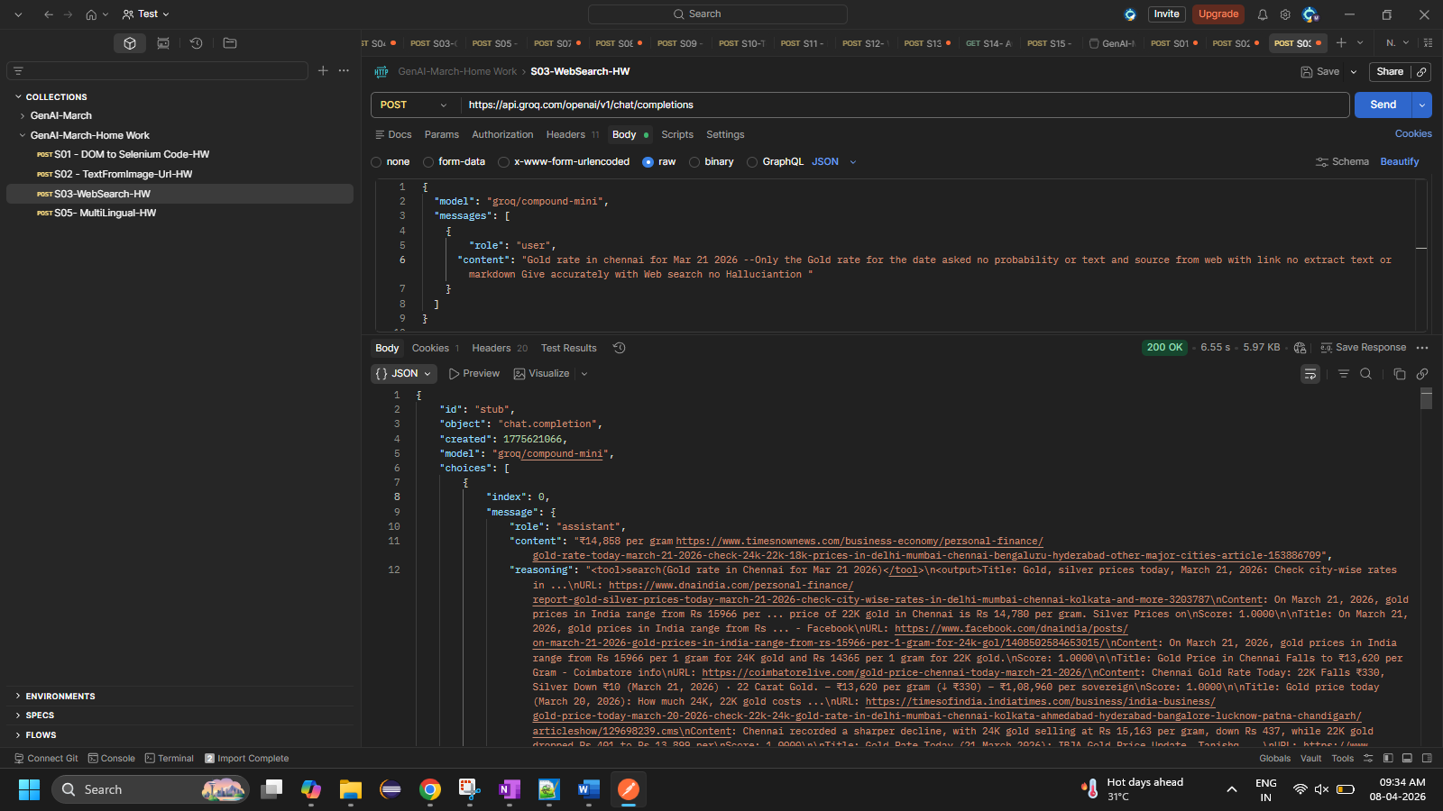

4. This is the api we request model to answer the question in the same language what User used
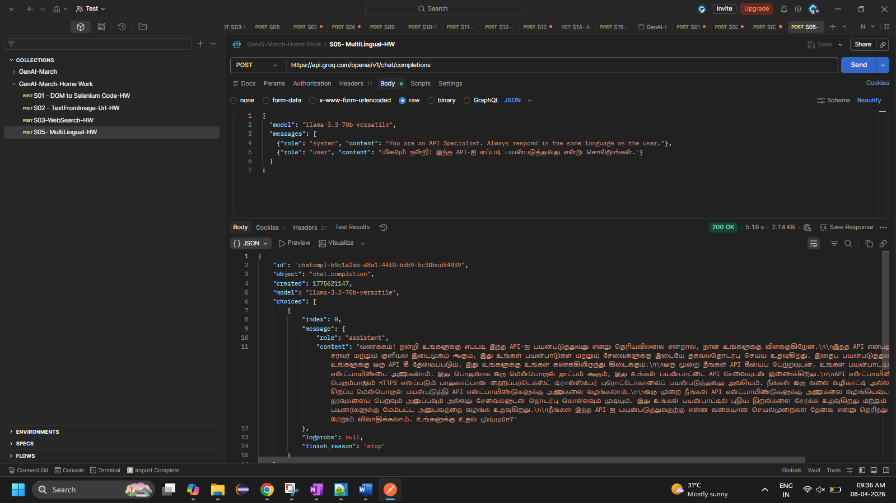

My question,
